Name: Jacob Beaudin

**Mid term**

This exam consists of four exercises and is worth 20 points. In case of a doubt, make a reasonable assumption, write it down, and go on.

Please provide short, precise answers and *write legibly*. **Good Luck**!

**Exercise 1** [ 5 points]

Consider the following tree structure for files and directories in Unix (directories are boxed, to distinguish them from files):

/

F2

F5

F1

F3

F4

F6

F7

a3.c

F9

a1.htm

F8

a2.txt

Assume that your home directory is F6, and your current working directory is F8.

1. Write a *single* Unix command that changes your current directory to F8. *Use paths relative to your home directory in your command (****not*** *starting at the root or at the current directory)*:

# cd ../../F4/F8

1. Your current directory is now F5. Write a *single* Unix command that copies the file a1.htm from F6 into your current directory. *Use paths relative to your current directory in your command (****not*** *starting at the root or at your home directory)*:

# cp ../../F1/F3/F6 a1.htm

1. Write a *single* Unix command that removes the directory **F5** and all its contents. Use paths starting at the root in your command (**not** starting at your home or current directory):

# rm -r //F2/F5

**Exercise 2** [5 points]

Write a program that splits an input from a user that contains a single occurrence of the ‘@’ character. Your program should print the two substrings separated by ‘@’ on separate lines, using the “%s” format specifier for printf. (You may print individual characters with putchar or “%c”.). You need to show your work in a C file, and compile and run it using gcc commands. Show your code and screenshot of how the code ran.

Here are two examples showing the function behavior:

|  |  |
| --- | --- |
| Program input from user | Output |
| **place@here** | **place**  **here** |
| **do@that** | **do**  **that** |

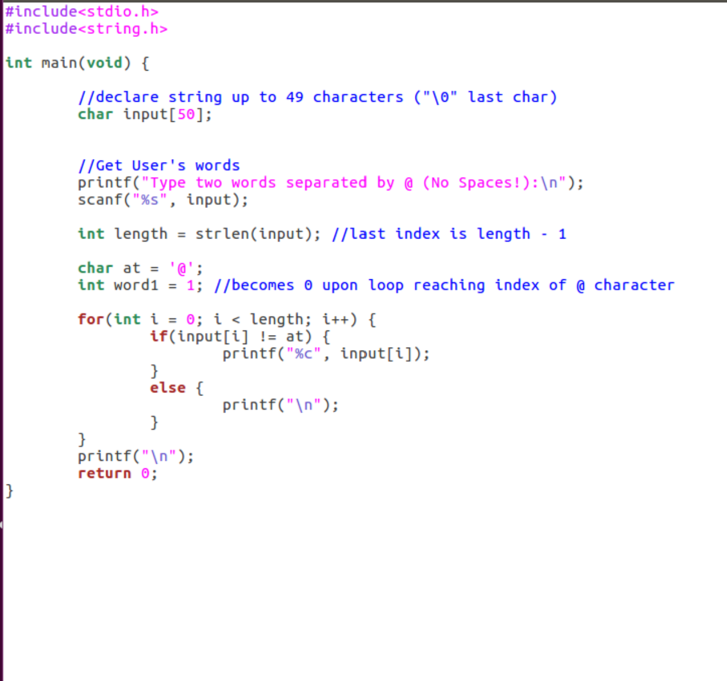

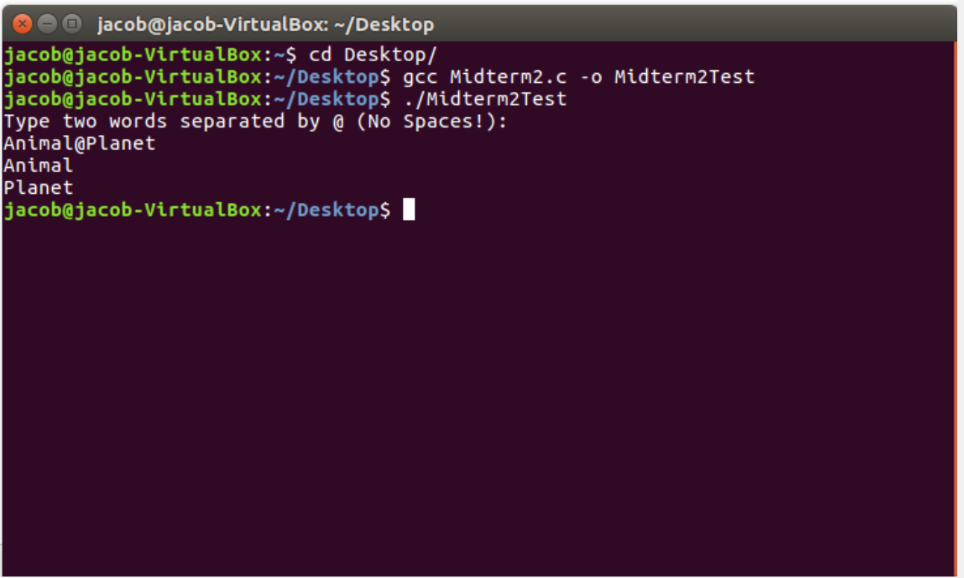

**Exercise 3** [Two’s Complement, 5 points]

Assume that only 5 bits are available for representing integers, and signed integers are represented in 2’s complement.

1. What is the *largest* value you can represent on 5 bits in 2’s complement?

01111 = 15

1. What is the *smallest* value you can represent on 5 bits in 2’s complement?

10000 = -16

1. What is the *smallest* value you can represent on 5 bits in 1’s complement?

1000 = -15

1. How is the decimal number 99 represented as an *eight-bit binary number*?

0110 0011

1. What is the representation in *hexadecimal* notation of 99?

63

1. How is **-99** represented in *2’s complement* on 8 bits?

1001 1101

**Exercise 4** [Bit-level and Logical Operations, 5 points]

*Assume an 8-bit two’s complement representation* for integer values. Suppose that **a** and **b** are integers with values **0xAB** and **0x35**, and all right shifts use sign extension. Fill in the table below indicating the values of the different C expressions.

***a = 0xAB = 10101011(2)***

***b = 0x35 = 00110101(2)***

|  |  |  |
| --- | --- | --- |
| Expression | Value (binary) | Value (hexadecimal) |
| **a | b** | **10111111** | **0xBF** |
| **~(a ^ b)** | **01100001** | **0x61** |
| **(!a) | b** | **00110101** | **0x35** |
| **(~a) && b** | **Not Zero: 1 (True)** | **0x01** |
| **(~(a & b)) >> 2** | **11110111** | **0xF7** |